**Lab 12**

**Speech and Image Processing**

Group assignment up to 3 students per group.

**Abdul Ghaffar Kalhoro**

**M. Rahman Rabbani**

**Hamad Nasir**

**Question** 10 marks

**Using MATLAB/Octave, given a clean text image x (example in Figure 1 below), break it into separate lines of text and save each line into a separate jpg file. The code should automatically do this for a given input text image file.**

**Hint:** Some starting code is given below

close all; % close all figures

x = imread('ocr_text.jpg'); % read input file

x=double(x);

[r,c]=size(x); % find rows and columns of image x

figure,imshow(x,[]); % show x on screen

x2(:,:,1)=x;

x2(:,:,2)=x;

x2(:,:,3)=x;

i=1;

% cutting a portion of x image and saving it as 1.jpg

imwrite(x2(50:100,:,:)/256, strcat(int2str(i),'.jpg'));

end

**Deliverables:**

MATLAB/Octave code file ***ocr_lines.m***

Input image ***ocr_text.jpg.*** Each group should have a separate input image

Output images ***1.jpg to n.jpg*** each image having separate line of text

**Example**

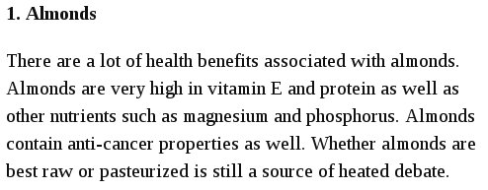

Figure 1. Input image “ocr_lines.jpg”



Figure 2. First line saved as “1.jpg”



Figure 3. Second line saved as “2.jpg”

**Solution:**

**clear all**

**close all**

**clc**

**image=imread('input.jpg');**

**figure(1)**

**imshow(image)**

**drawnow**

**img_1=image(:,:,1)<150;**

**figure(2)**

**imshow(img_1)**

**drawnow**

**se=strel('disk',1);**

**img_2=imdilate(img_1,se);**

**figure(3)**

**imshow(img_2)**

**drawnow**

**[lab,num]=bwlabel(img_2);**

**for i=1:num**

**[r,c]=find(lab==i);**

**img_3=image(min(r):max(r),min(c):max(c),:);**

**figure(4)**

**%subplot(3,3,i)**

**imshow(img_3);**

**%drawnow**

**end**

**OUTPUT**











